I’m going to explore Centred Shape Number Sequences.
That is when a number related to a shape is placed around the smaller one.
I’m going to explore the Centred Triangles. Here are the first five:
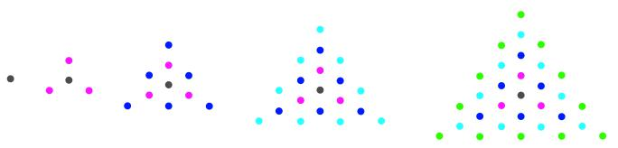
You may notice the single black in the middle. The first of any of these sequences is always 1 even though it’s hardly a triangle (or square or cube etc.).

Let’s imagine I've been asked the following:
Make a visual proof that the relationship in bold is true.
4th Centred Triangle [CT] - 4th Triangular Number [T] = 3rd Square Number [Sq]

(or N^{th} CT - N^{th} T = (N-1)^{th} Sq)

I could approach this is different ways. Here are some examples:

A/
I draw it like this but I start using the 5th CT as it was easier for the illustration.
It shows the 5th CT (Red & Green) minus 5th T (Red) leaving the Green. The parts can be moved to show a square 4²:

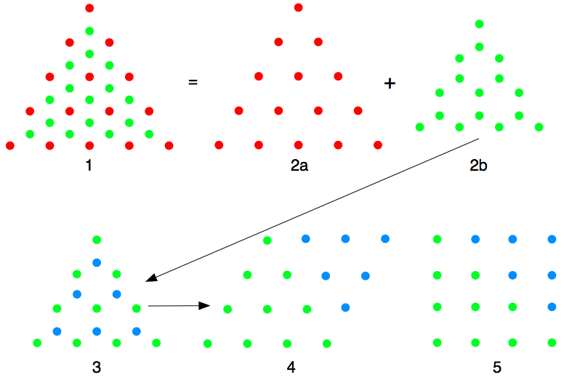

Here it is in more detail. The pictures above show the 5th CT (Red & Green) [1] equalling the 4th T (Red)[2a] plus the Green shape [2b].
[3] shows two separate Triangular Numbers (Blue and Green). The Green triangular number is then moved across and is joined by the flipped Blue Triangular number [4], which is squashed to make [5] being 4².

With the next smaller CT, it works out in just the same way:

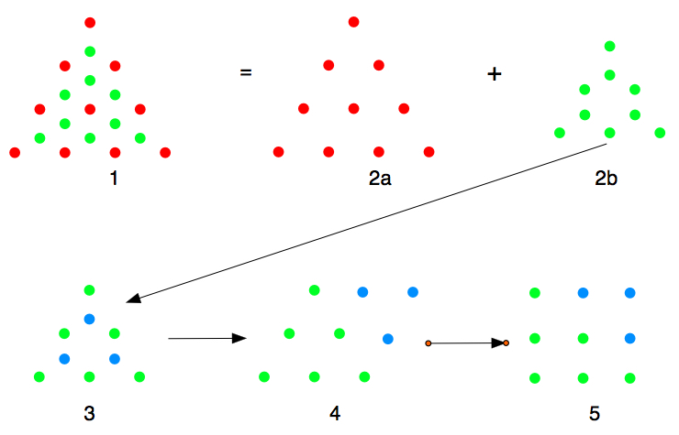

So this could be expressed as N^{th} T + (N-1)² = N^{th} CT.

B/
I explored again and found it can be see this way, by looking at the sloping arrangements of the green going 1, 2, 3, 4, 3, 2, 1 & 1, 2, 3, 2, 1 in both the triangles and the square.

The sloping lines of dots below go green, red, green, red etc. Then removing the red triangular number leaves the greens that go 1, 2, 3, 4, 3, 2, 1 (CT 4) and 1, 2, 3, 2, 1 (CT 3):

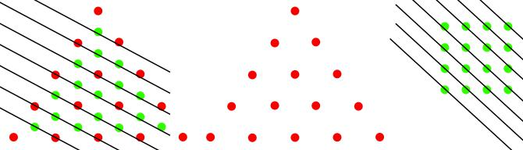

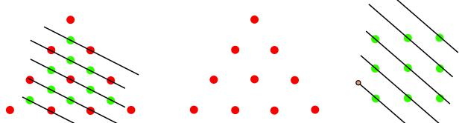

C/ Then I explored and found I could make house shapes:

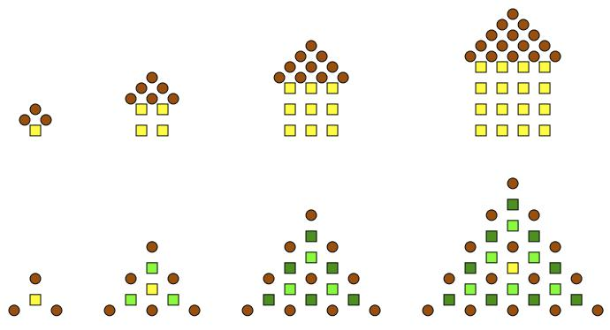

The right angled isosceles triangle roof is sitting on a square house. When placed together, they produce a Centred Triangle. So this time we are starting with a triangular number and placing it on a square number. It therefore becomes:

3rd Square Number [Sq] + 4th Centred Triangle [CT] = 4th Triangular Number [T]

D/
I then looked at it in a slightly different way to A/ and used CT 3, 4 and 5, and this time I counted at the final stage:

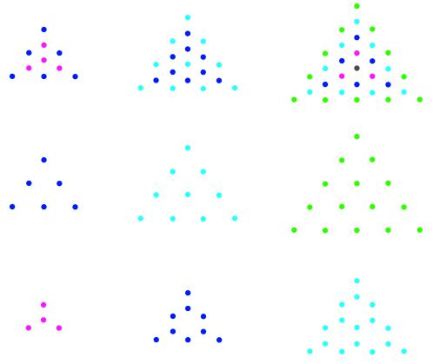

Here we look at the dots that are left when the triangular number is removed from the CT.
Looking at the array of those dots that are left and counting them in horizontal lines from the top, I have:

CT 3 1, 1, 2 can be written as 2 + 2 or 2²
CT 4 1, 1, 2, 2, 3 can be written as 3 + 3 + 3 or 3²
CT 5 1, 1, 2, 2, 3, 3, 4 can be written as 4 + 4 + 4 + 4 or 4²

